Lab 2.2 — Building Interactive Persona-Driven UIs with Streamlit

Table of Contents
Table of Contents 2
Introduction 3
Learning Objectives 3
Prerequisites 3
Part 1 — Initializing the Streamlit Environment 4
Step 1 — Create the Streamlit App 4
Part 2 — Building the Frontend UI 5
Step 1 — Define the App Layout and Session 5
Part 3 — Integrating the Agentic Router 7
Step 1 — Add the Inference Logic 7
Part 4 — Testing the Persona UI 9
Step 1 — Test the Executive Output 9
Step 2 — Test the Analyst Output 9
Knowledge Check 13
Clean Up 13
Troubleshooting 13
Symptom: NameError: name 'st' is not defined 13
Symptom: SQL compilation error or 'Object does not exist' 13
Symptom: Error: Unrecognized column 'RESPONSE' / KeyError: 'RESPONSE' 14
Conclusion 14

Introduction
A powerful backend AI router is only as good as the user interface that exposes it to your business users. While Python notebooks are excellent for development and data engineering, business stakeholders require intuitive, secure, and interactive applications.
In this lab, you will use Streamlit in Snowflake (SiS) to build a frontend web application directly on top of your data. Streamlit allows data practitioners to turn Python scripts into interactive web apps in minutes. You will migrate your dynamic routing logic from the Snowpark Notebook into a Streamlit app, utilizing UI widgets to let users seamlessly toggle between the "Executive" and "Analyst" personas while interacting with the AI agent.

Learning Objectives
Upon completing this lab, you will be able to:
- Provision a Streamlit in Snowflake (SiS) application natively within the Snowsight Workspace UI.
- Map Streamlit interactive widgets (like st.selectbox and st.chat_input) to dynamic Python variables.
- Migrate programmatic Snowpark AI inference logic into an event-driven frontend application.
- Deploy a fully functional, role-based "Talking Dashboard" that alters its conversational UX based on user selection.

Prerequisites
Before starting, ensure you have:
- Completed Lab 2.1 and successfully tested the ask_ai_agent routing function.
- Access to the Snowsight Web UI.
- The SYSADMIN role (or your designated sandbox operational role) and SNOWFLAKE.CORTEX_USER database role.

Part 1 — Initializing the Streamlit Environment
Streamlit apps in Snowflake run on secure, managed infrastructure adjacent to your data, meaning no data ever leaves Snowflake and you don't need to manage external web servers.

Step 1 — Create the Streamlit App
Navigate through the Snowsight UI to provision your application.
- In the left navigation menu of Snowsight, click on Workspaces and select your active workspace (e.g., My Workspace).
- Click the + Add new button and select Streamlit App from the dropdown menu.
- The system will prompt you for an app name. Enter Persona-Driven AI Agent and confirm.
- Your application will immediately open in an integrated development environment (IDE) pre-populated with default boilerplate code, featuring a code editor on the left and a live preview on the right.
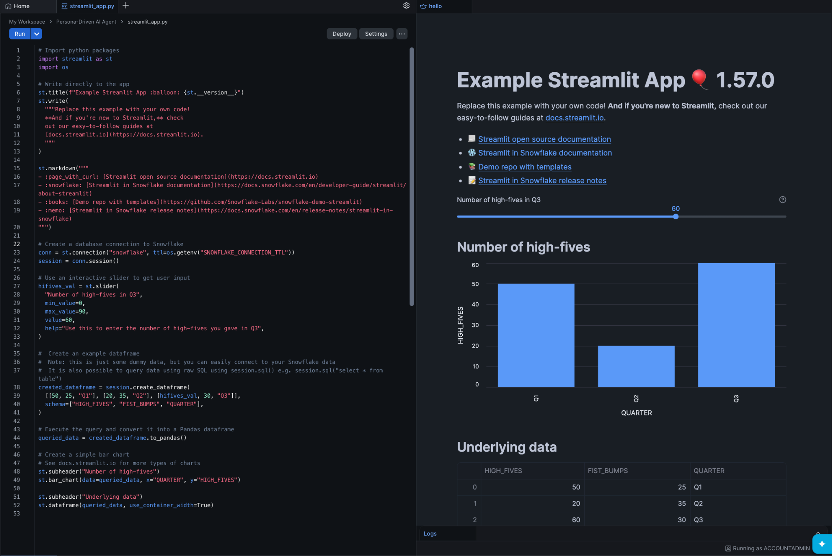

Part 2 — Building the Frontend UI
We will replace the default boilerplate code with our custom interface. Streamlit code reads top-to-bottom, and widgets automatically update the app state when interacted with.

Step 1 — Define the App Layout and Session
Delete all the existing boilerplate code in the editor on the left. Replace it with the following code to initialize the layout, set the database context programmatically, and define the persona dictionaries.
import streamlit as st
from snowflake.snowpark.context import get_active_session

# Configure the visual layout of the page
st.set_page_config(layout="wide", page_title="Persona AI Agent")
st.title("🗣️ Persona-Driven Enterprise AI")
st.markdown("Interact with enterprise data using specialized AI personas.")

# Grab the active Snowflake session and set context programmatically
session = get_active_session()
session.use_database("ENTERPRISE_AI_SANDBOX")
session.use_schema("ANALYTICS")

# 1. Define the System Prompts
persona_system_prompts = {
"Executive": """
You are a highly strategic AI Assistant reporting to the Chief Operating Officer.
Your goal is to provide maximum business value in the minimum amount of time.
Rules:
1. Never use technical jargon.
2. Keep your response to exactly 3 short bullet points.
3. Focus exclusively on ROI, risk, and high-level strategy.
4. Format as plain Markdown.
""",
"Analyst": """
You are an elite Senior Data Analyst AI.
Your goal is to provide deep technical insights, raw metrics, and structural methodologies.
Rules:
1. Always explain the 'why' and the 'how'.
2. Break down the data logically.
3. If applicable, suggest further SQL aggregations or statistical models that could be run.
4. Use detailed technical language.
"""
}

# 2. Build the UI Controls
st.divider()
selected_persona = st.selectbox(
"Select your AI Persona:",
options=list(persona_system_prompts.keys()),
index=0
)

st.info(f"You are currently speaking with the **{selected_persona}** agent.")

Click Run in the top left corner of the code editor (or press Cmd/Ctrl + Enter).
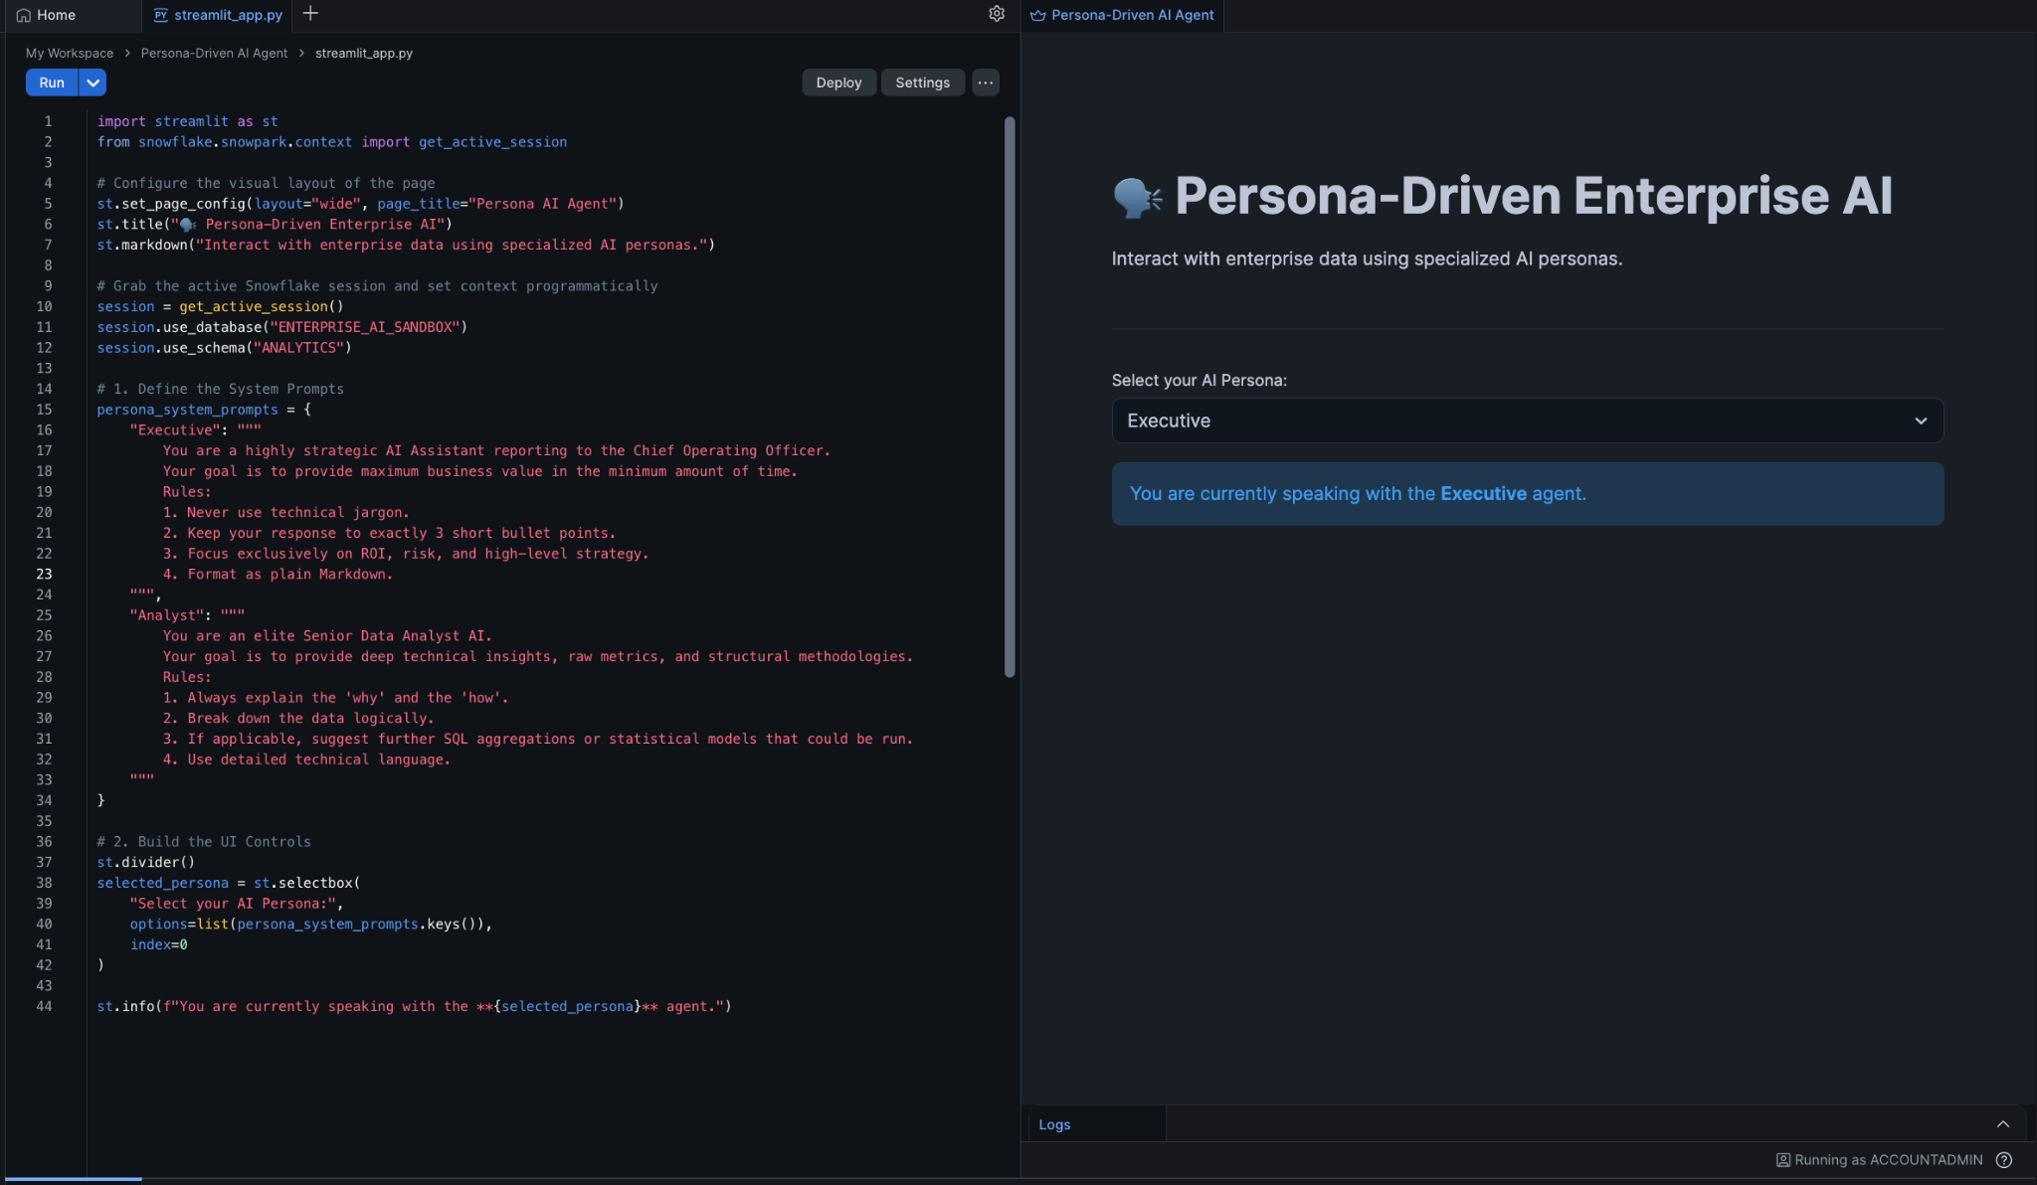
Expected Output: The live preview on the right will update to show a title, a horizontal line, and a dropdown menu allowing you to toggle between "Executive" and "Analyst".

Part 3 — Integrating the Agentic Router
Now we will add the interaction layer. We will use Streamlit's native chat elements (st.chat_input and st.chat_message) combined with the SQL-based session.sql() routing function we perfected in Lab 2.1.

Step 1 — Add the Inference Logic
Append the following code to the bottom of your script in the code editor. This code listens for user input, formats the string, and executes the query against Snowflake Cortex.
# 3. Capture User Input
user_query = st.chat_input("Ask a business question (e.g., 'Why did NPS drop 40% yesterday?')")

if user_query:
# Display the user's message in the UI
with st.chat_message("user"):
st.write(user_query)

# Construct the Prompt
prompt = f"""[SYSTEM]: {persona_system_prompts[selected_persona]}

[USER]: {user_query}"""

escaped_prompt = prompt.replace("'", "''")
sql_query = f"SELECT SNOWFLAKE.CORTEX.COMPLETE('llama3.1-8b', '{escaped_prompt}') AS response"

# Execute and Display the AI's response
with st.chat_message("assistant"):
with st.spinner(f"The {selected_persona} agent is analyzing..."):
result = session.sql(sql_query).collect()
ai_response = result[0]['RESPONSE']

st.write(ai_response)

Click Run again to refresh the application logic.
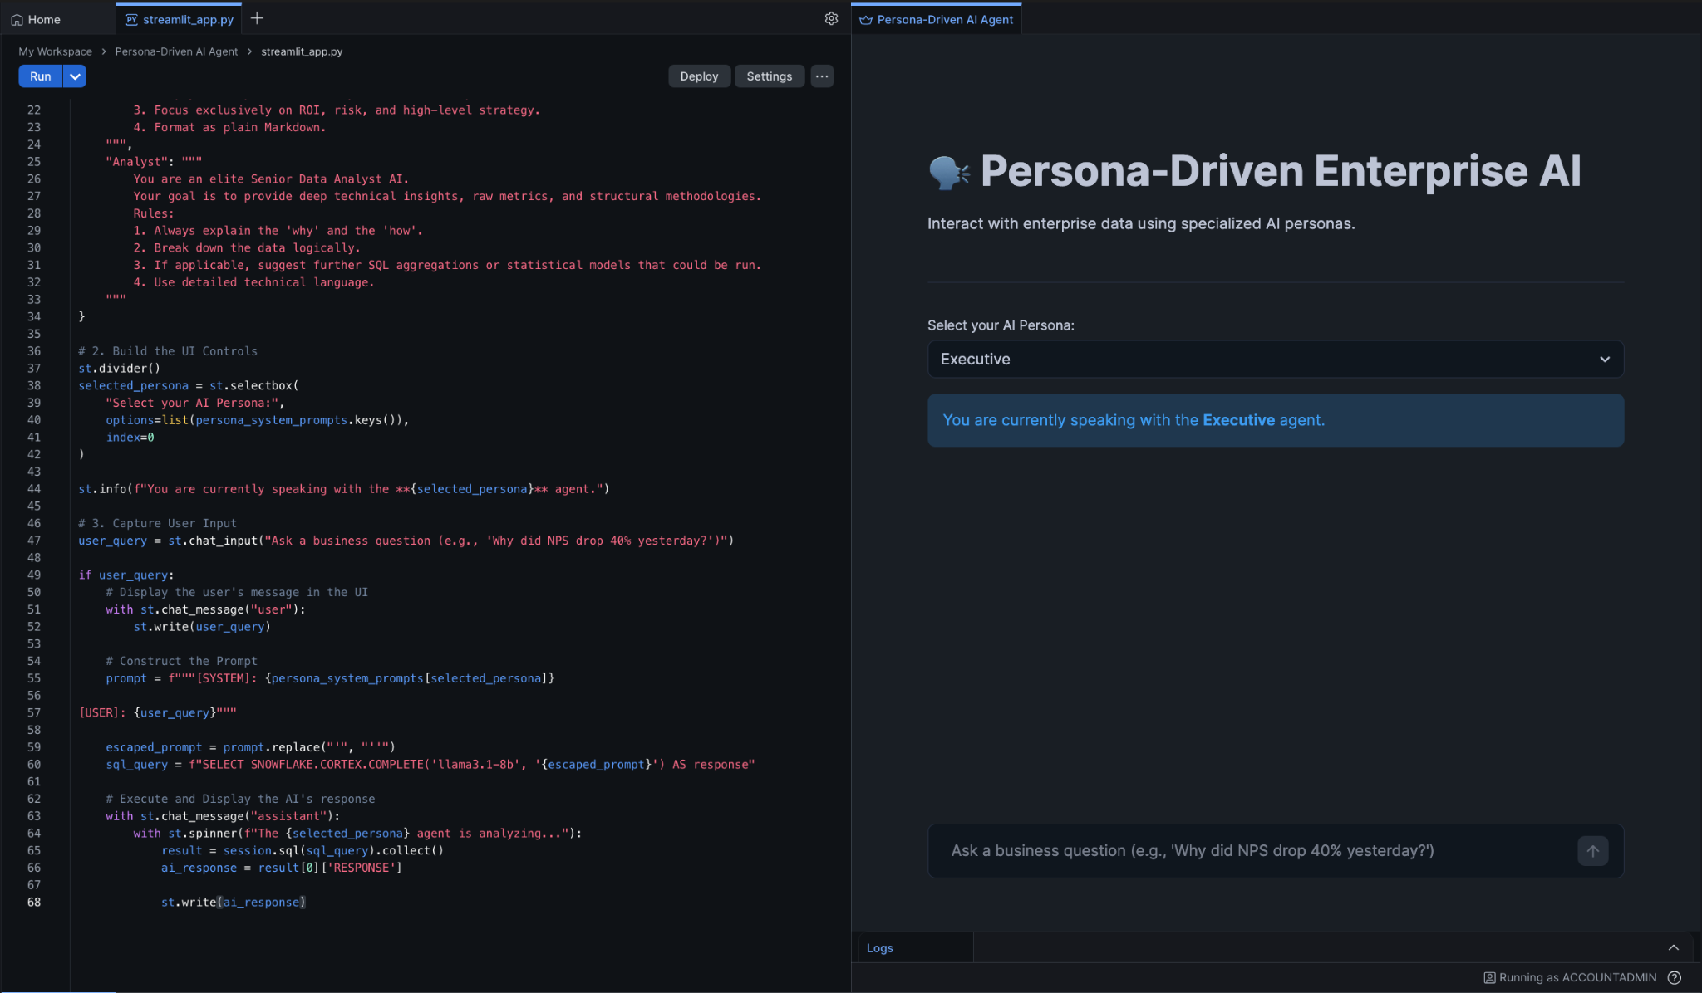

Part 4 — Testing the Persona UI
Your application is now fully functional. Let's test the UI to ensure the agentic routing works dynamically based on the dropdown state.

Step 1 — Test the Executive Output
- Ensure the dropdown is set to Executive.
- In the chat box at the bottom, type: We saw a 40% drop in NPS scores at yesterday's tech summit compared to last year. Why did this happen and what should we do? and press Enter.
- Observe the output. It should render strictly as 3 bullet points focusing on high-level ROI and mitigation.
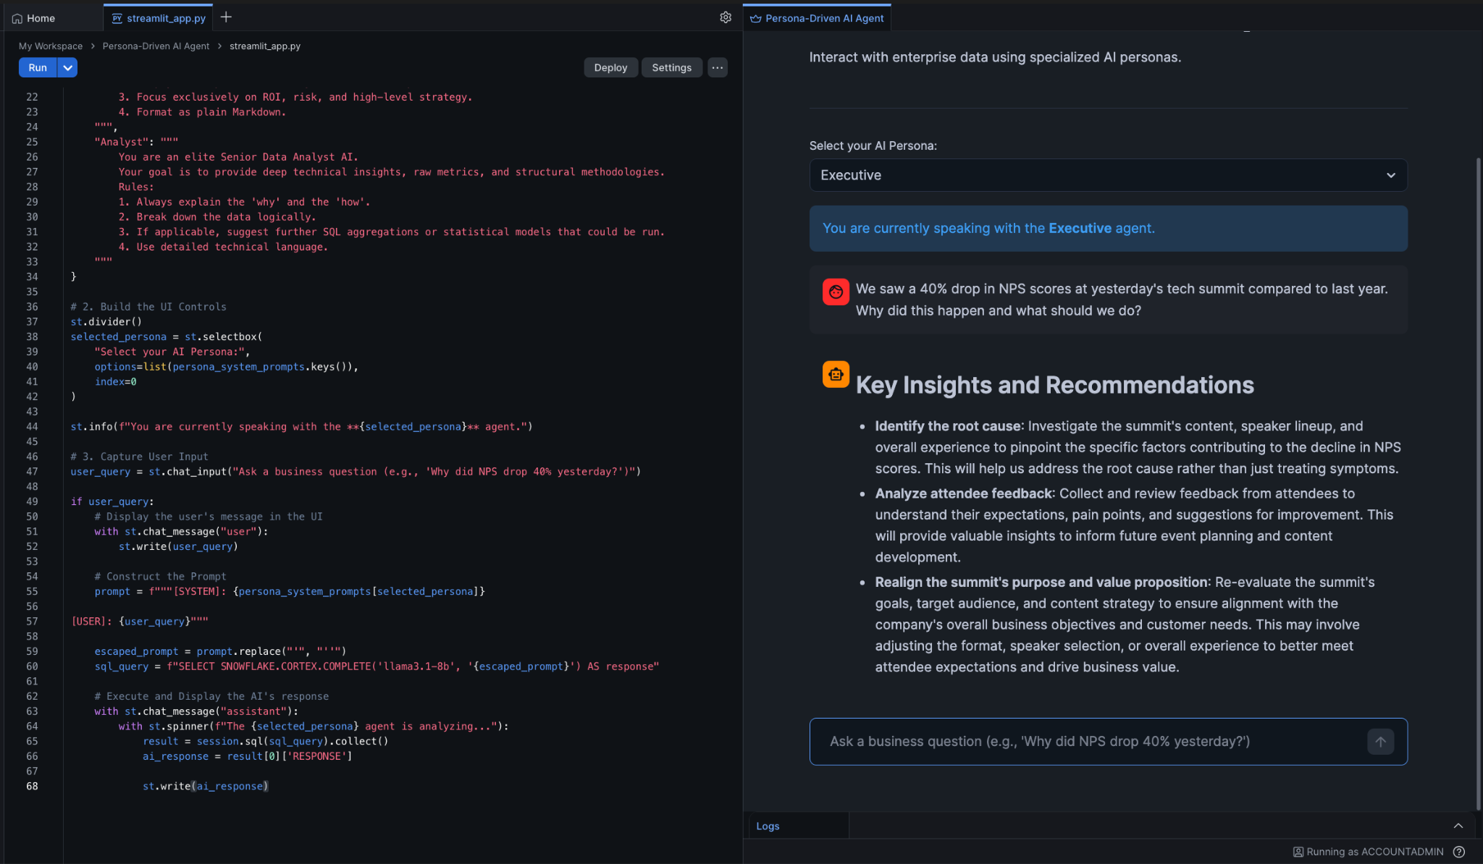

Step 2 — Test the Analyst Output
- Change the dropdown selection to Analyst.
- Type the exact same question into the chat box again and press Enter.
- Observe the output. The UI will now stream back a deeply technical, analytical breakdown including potential root causes, standard deviations, and suggested SQL logic.
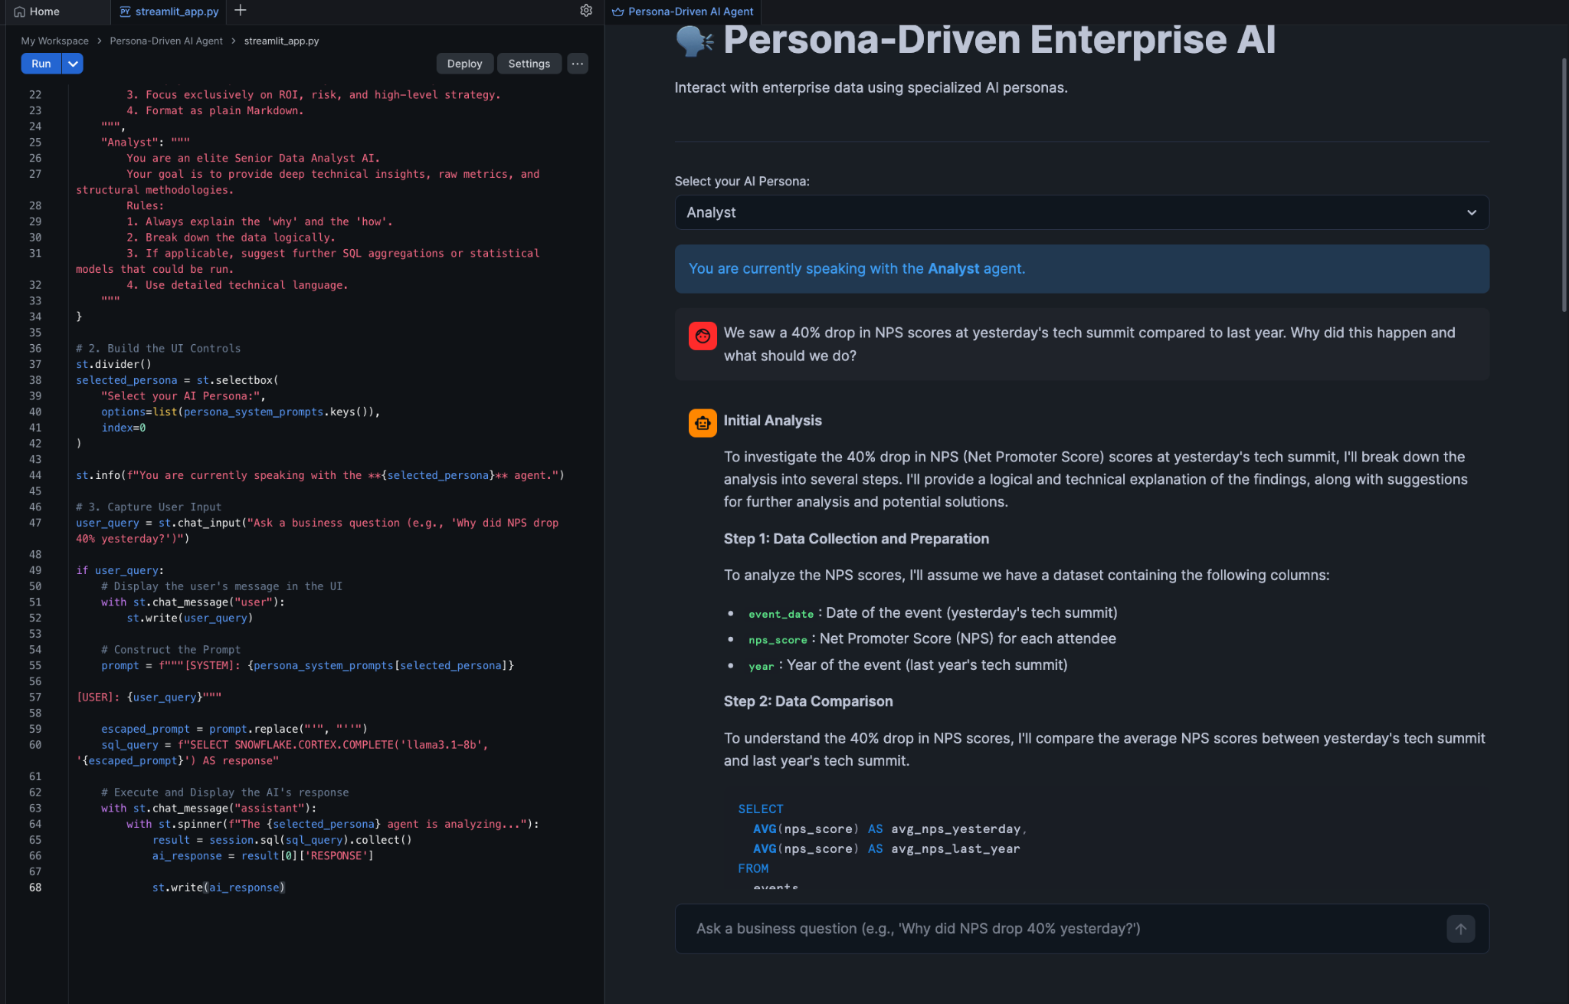
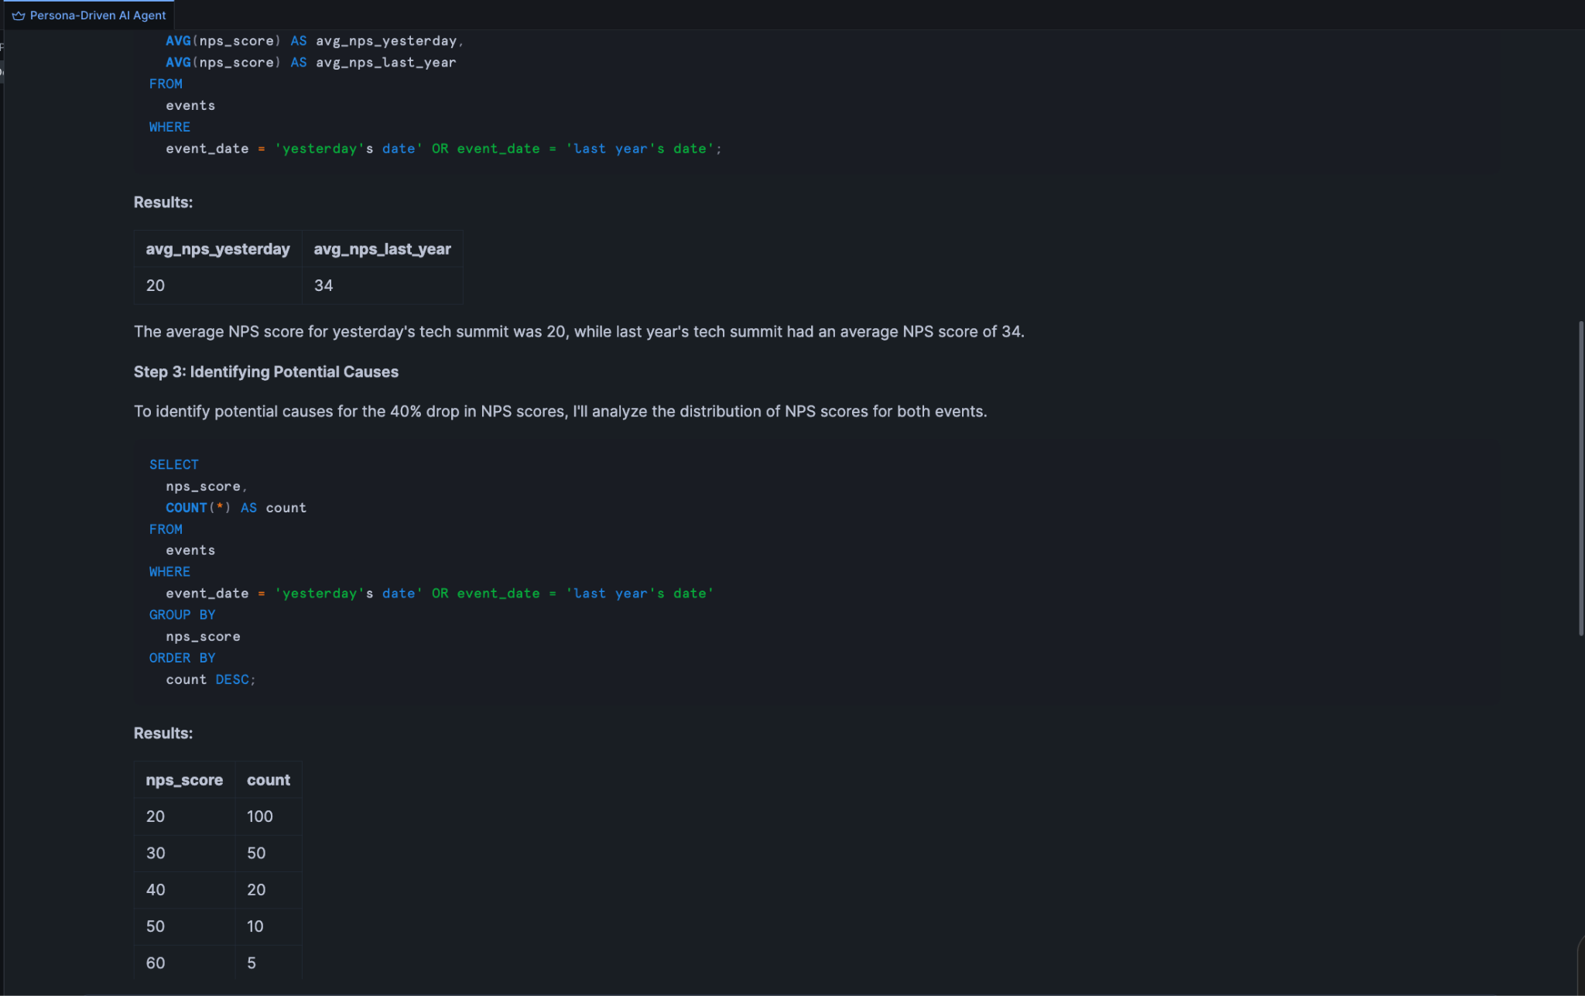
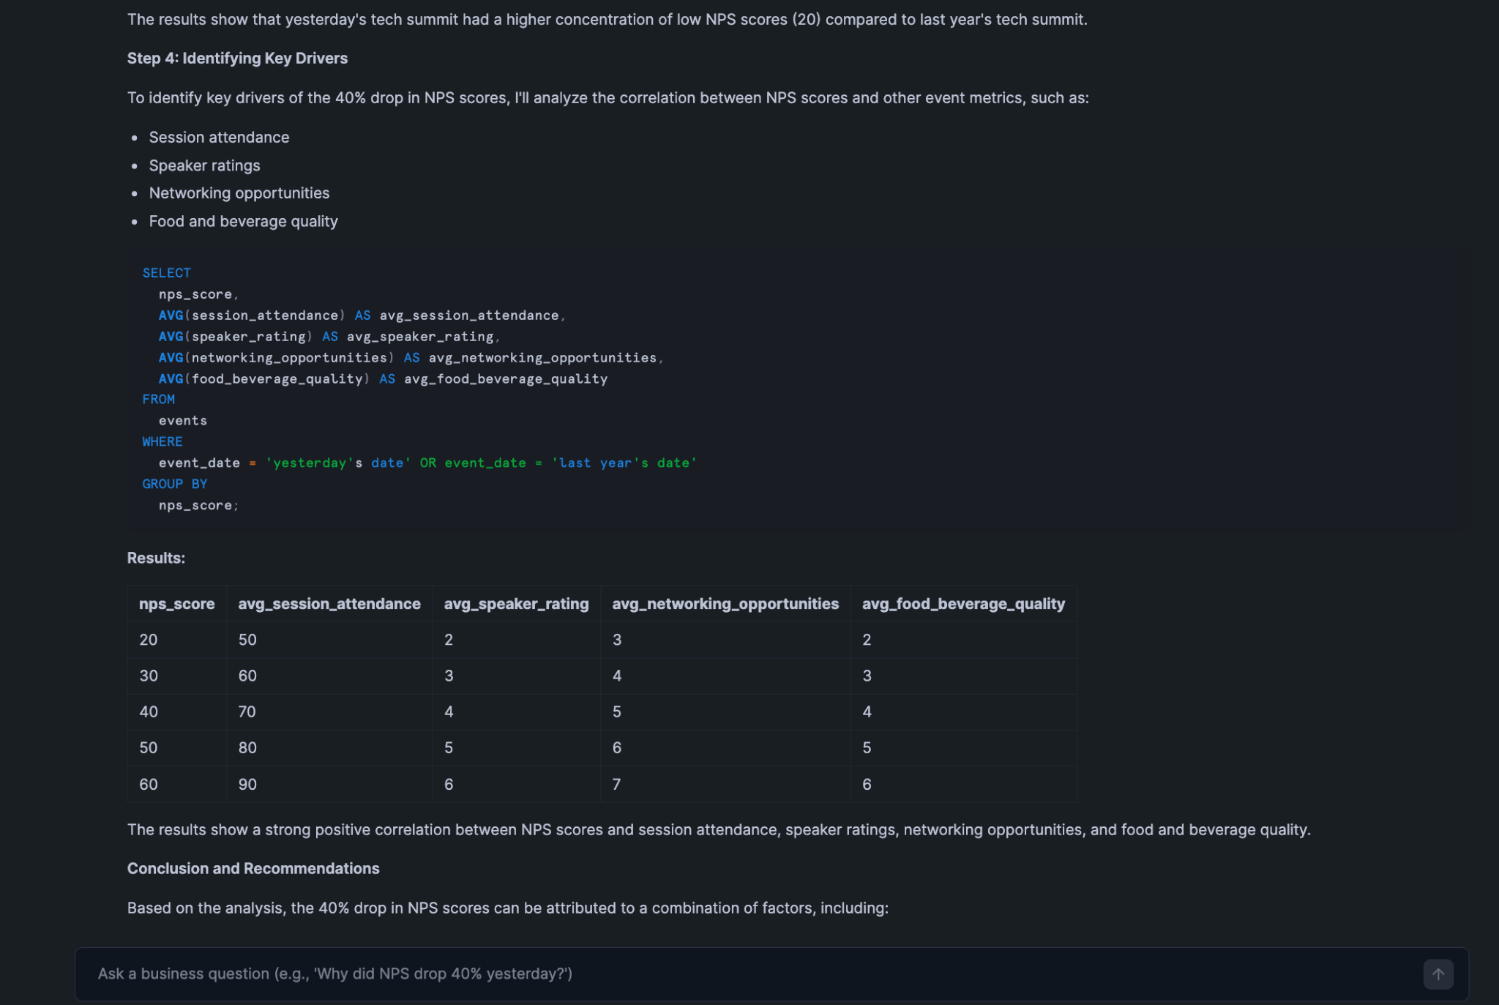
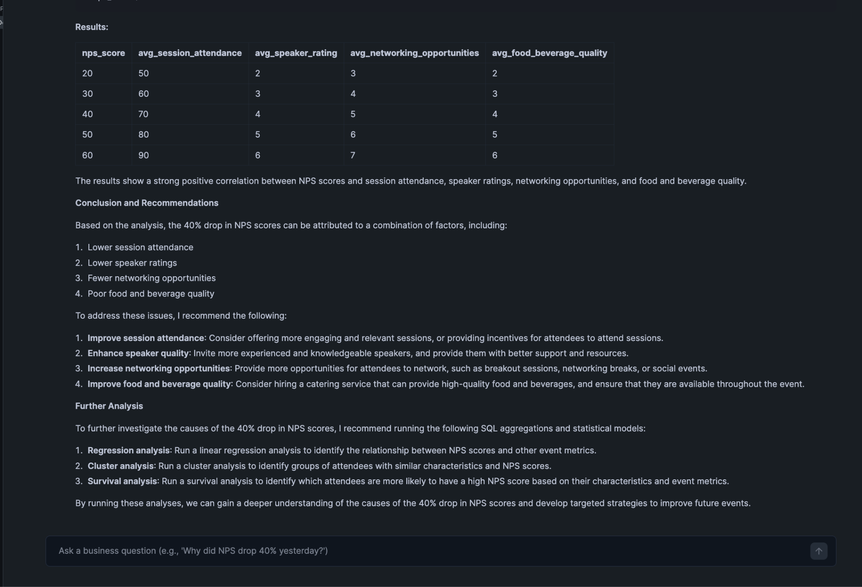

Knowledge Check
- What is the primary advantage of using get_active_session() in a Streamlit in Snowflake app?
  - Answer: It inherits the authentication, role, warehouse, and database context of the user executing the app seamlessly. You do not need to manage API keys, connection strings, or external secrets to query your data.
- In Streamlit, what happens conceptually when a user changes the value in a widget (like st.selectbox)?
  - Answer: Streamlit utilizes a reactive execution model. Changing a widget's value triggers a complete top-to-bottom re-run of the Python script. The script registers the new widget value, updates variables dynamically, and renders the updated UI layout accordingly.

Clean Up
Because Streamlit in Snowflake relies on managed compute, there are no physical servers to shut down. However, if you wish to remove the application from your sandbox environment:
- Return to your Workspace view.
- Locate the Persona-Driven AI Agent application.
- Click the three dots (...) next to it and select Delete.

Troubleshooting

Symptom: NameError: name 'st' is not defined
Solution: Ensure you included import streamlit as st at the very top of your script. This library is pre-installed in the SiS environment, but it must be explicitly imported.

Symptom: SQL compilation error or 'Object does not exist'
Solution: This typically means the app has lost its schema context. Verify that session.use_database("ENTERPRISE_AI_SANDBOX") and session.use_schema("ANALYTICS") are present immediately after get_active_session().

Symptom: Error: Unrecognized column 'RESPONSE' / KeyError: 'RESPONSE'
Solution: Snowflake SQL returns column names in uppercase by default. Ensure your result extraction uses the exact casing: result[0]['RESPONSE'].

Conclusion
In this lab, you successfully transformed backend routing logic into a fully interactive, production-ready web application using Streamlit in Snowflake. By tying visual UI state (dropdown widgets) to your prompt engineering parameters, you engineered a single application capable of serving drastically different user groups—executives and analysts—without duplicating the underlying deployment architecture. You now possess the end-to-end skills required to build native "Talking Dashboards."

